

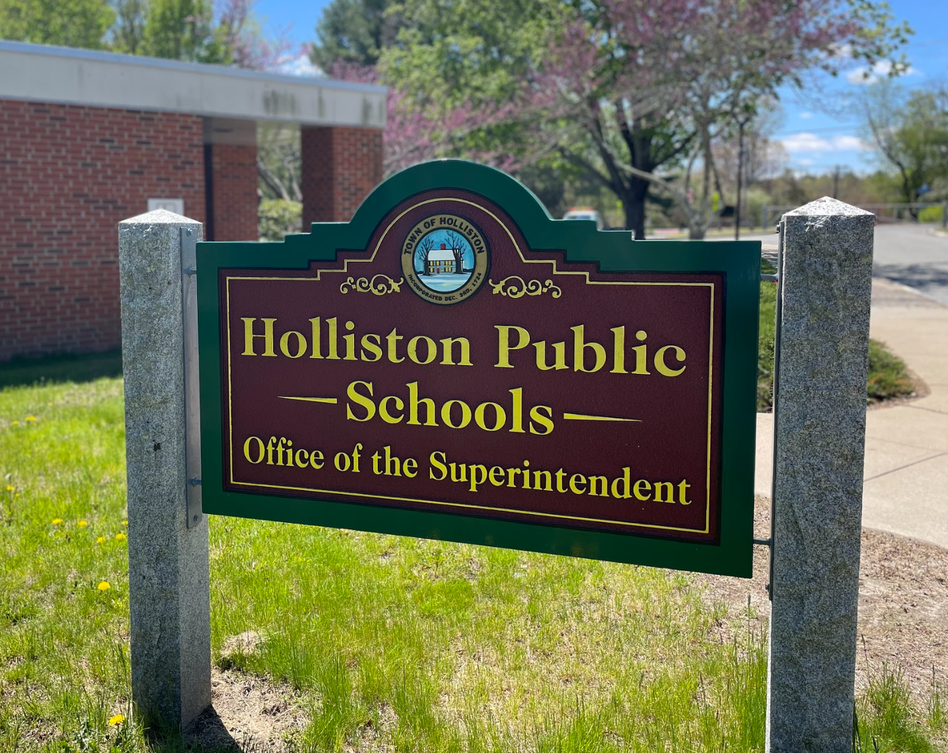

Student Services Family Resource Guide
(updated Fall 2024)

Table of Contents

- Holliston Student Services Purpose
- Holliston SEPAC
- Our Special Education Process
- What is a 504?
- Difference between a 504 & an IEP
- Our Early Childhood Procedures
- Holliston Public Schools Continuums
- What do we mean by our acronyms?
- Resources

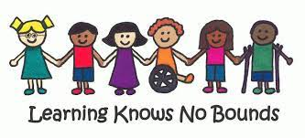

Holliston Student Services Purpose
Holliston Student Services is composed of administrators, teachers, specialists, counselors, psychologists, and behaviorists who work to ensure the needs of ALL students are being met within the Holliston Public Schools. We feel it is imperative that you and your child’s journey through Holliston Public Schools feels supportive, but most importantly highly engaging and consistent from start to finish. Communication is key to creating and maintaining a productive Team relationship for you and your student, and we look forward to being here as your support system.

Holliston Public Schools Special Education Administration
Jessica Beattie | Director of Student Services | (508) 429-0662 ext 1121  beattiej@holliston.k12.ma.us
Mary Perry | Placentino Elementary  Preschool Coordinator | (508) 429-0647 ext 1251  perrym@holliston.k12.ma.us
Lisa Robinson | Placentino Elementary  Student Services Administrator | (508) 429-0647 ext 1205  robinsonl@holliston.k12.ma.us
Emily Luuri | Miller Elementary  Student Services Administrator | (508) 429-0667 ext 1332  luurie@holliston.k12.ma.us
Tessa Piantedosi | Robert Adams Middle School  Student Services Administrator | (508) 429-0657 ext 1405  piantedosit@holliston.k12.ma.us
Kim Condon | High School  Student Services Administrator | (508) 429-0677 ext 1104  condonk@holliston.k12.ma.us

Holliston SEPAC
Special Education Parent Advisory Council
The mission of the Holliston SEPAC is to fulfill the requirements set forth in Massachusetts General Law 776 and to work toward the understanding, respect, support, and appropriate education for all children with special needs in our community.

SEPAC Overview
- SEPAC is comprised of parents/guardians of students who are in Special Education or on 504 plans. This group is an open forum that meets once a month and all are welcome to join.
- SEPAC is specifically aimed at families of children with special needs
- SEPAC is intended to be a communication and feedback channel for parents whose children receive special education services
- SEPAC communicates information on parental concerns to the respective school contacts and meets and interacts with school officials to evaluate and develop special education programs
SEPAC Goals
- To provide outreach opportunities and a network of support for parents, including access to relevant information, regulations and laws, training, and emotional support
- To collaborate with the school district and school committee to continually improve the educational opportunities available within our school community that prompt optimal outcomes for children with disabilities
- To promote communication within the elementary, middle, and high schools to foster a sense of unity and understanding of the issues and solutions necessary to improve the effectiveness of the special education services within our school system. Events are defined but not limited to: Family Ed Events, Guest Speakers, Trunk or Treat, Coffee Talks, etc.
SEPAC Bylaws

The Holliston SEPAC welcomes all questions and communication relative to your child’s needs in the Holliston Public Schools. You can reach them at hollistonsepac@gmail.com and follow them on Facebook at “Holliston SEPAC”

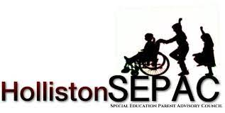

Our Special Education Process
The Team's responsibility is to identify an Educational Disability, as defined by law. Eligibility for special education is based on educational disabilities, and not on a specific diagnosis. Diagnosis is medical in nature; school teams do not diagnose.
The "Team" may include the following members:
- The child’s parents/guardians
- Student Service Administrator (SSA) who is qualified to supervise or provide special education/is knowledgeable about the general curriculum/is knowledgeable about the availability of resources in the district/a representative of the district who has the authority to commit the resources of the district
- Regular education teacher
- Special education teacher/liaison
- The student (ages 14 and older)
- An individual qualified to interpret instructional implications of evaluation results
- Others determined necessary by the Administrator of Special Education
- Other individuals at the request of the student’s parents; i.e. neuropsychologists, speech and language pathologists, therapists, advocates, etc.
- A representative of any public agency who may be responsible for transition services

For Initial evaluations, assessments are completed in all area(s) of suspected disability. State regulations identify the following disability categories:
  - Autism
  - Developmental Delay
  - Intellectual Impairment
  - Sensory: Hearing, Vision, Deaf-Blind
  - Neurological Impairment
  - Emotional Impairment
  - Communication Impairment
  - Physical Impairment
  - Specific Learning Disability
  - Health Impairment
At each “initial and 3 year” the following FlowChart will be used to determine eligiblity.
Initial evaluations and 3-year re-evaluations are chaired by building-based Student Service Administrators (SSAs).
All annual reviews are chaired by the special education liaisons.
For initial evaluations and reevaluations, the three-pronged approach to special education determinations is followed utilizing the special education eligibility form.
If no determination of special education eligibility is found, a consideration of a Section 504 meeting to consider eligibility for an accommodation plan should be made. A separate team meeting would follow to determine eligibility under Section 504, outside of the Special Education process.
Consideration is always given to general education support and/or the use of an District Curriculum Accommodation Plan (DCAP).

Event | Timeline
Parent requests an evaluation | The District has five (5) working school days to provide a written response
Child Age 2 1/2 Evaluation completed, eligibility determined | If eligible, program in place by (3rd) birthday
Evaluation: academic, psychological, SLP, OT, PT, FBA, etc...  *families can agree to all or select specific proposed evaluations from the team* | Testing completed thirty (30) working days from the date of signed consent
Evaluation Reports | Ready for parents two (2) calendar days prior to the TEAM meeting
TEAM Meeting | Scheduled within forty-five (45) working school days from written consent for evaluation. Also occurs within forty-five days allowing IEP to be sent out to parents within the forty-five days period.
IEP Documentation | If parent leaves with a summary, the district has two weeks to share the proposed IEP. If the team does not provide a summary, the parent must receive the IEP within 3-5 calendar days.
IEP or Response Notice | Parent/Guardian should sign or respond to the IEP within Thirty (30) days of receipt of the IEP
Parental Response to IEP | If the parent/guardian does not respond to the IEP or accept the IEP with a signature within 30 days, the district must send written notification to the Bureau of Special Education (BSEA)
Receipt of parental rejection or partial rejection of IEP | Upon receipt of the request, the district has five (5) working school days to respond---TEAM Meeting scheduled within ten (10) days of receipt of the report (For students on IEP)
Independent Evaluations | Upon receipt of an outside evaluation, a TEAM meeting is scheduled within ten (10) days of receipt of the report to consider the results of the evaluation. District can propose an evaluation and or screenings to compare to Outside Evaluation-should be completed within thirty (30) days.

What is a 504?
Section 504 of the Rehabilitation Act of 1973 is a civil rights law that prohibits discrimination based on disability in programs and activities that receive federal financial assistance. This law protects a person who has a physical or mental impairment that substantially limits one or more major life activities. Determination of eligibility for a 504 Accommodation Plan is a separate process from the special education eligibility process and is coordinated through the school’s counseling department.

A 504 requires that a student’s disability substantially limits a major life activity and requires accommodations, but not modifications or specialized instruction. If you feel your child meets the requirements for a 504, reach out to your building-based counselor who will be able to get the process started. 504 FlowChart

Difference between a 504 & an IEP

Both an Individual Education Plan (IEP) and a 504 Plan are legally binding documents that outline a student’s disability and the impact it has on learning. A 504 is NOT part of Special Education but is a federal document that MUST be followed by all education institutions. A 504 provides “accommodations” NOT “modifications” to a student's learning. An IEP IS part of Special Education, and is also legally binding, but provides BOTH “accommodations” and “modifications” to content and delivery of instruction.

Our Early Childhood Procedures

What is Child Find?
Holliston Public Schools has at least annual outreach and a liaison who works with the groups listed below. Students may be identified by these groups as students who may be in need of special education services.
  - Medical professionals/clinic health care agencies
  - Private nursery schools/daycare facilities
  - Parent organizations
  - Early intervention programs
  - Agencies serving migrant and/or homeless persons
Our Community Screening Process
Holliston Public Schools conducts developmental screenings for three and four-year-olds and all children of age to enter kindergarten. Such screenings are designed to review a child’s development and to assist in the identification of those children who should be referred for an evaluation to determine potential eligibility for special education. These screenings may be held multiple times during the school year and take place at the Placentino Elementary School.
Requests for screening can be made by parent/guardian and directed to the Preschool Coordinator, Mary Perry at perrym@holliston.k12.ma.us
Early Intervention Transition Services
Our school district encourages agencies serving the needs of young children to refer children for potential special education determinations of eligibility at or before 2 1/2 years of age to ensure continuity of services, as well as any family who feels their child, is in need of service that is between the ages of 2.5-4yrs old.



HOLLISTON PUBLIC SCHOOL CONTINUUMS & SERVICES
The school district has 3 continuums that provide a spectrum of specialized supports based on the specific student profiles that are integrated into each school setting as described below. The continuums are provided to qualifying students in grades PreK-12:

Network-BASIS
BASIS-Network continuum of services provides an alternative or modified curriculum and inclusive classroom support for students with a range of disabilities and needs, primarily students with significant developmental disabilities and cognitive challenges. Network services follow the curriculum frameworks, finding entry points matching grade level to student developmental level and ability. Functionally-based instruction can also be provided in a small group or one-to-one setting in various academic areas, educating students in a variety of formats. Services also include students being supported in inclusion settings. Network services for a student typically include activities of daily living, social language supports, and vocational skills which are an integral part of the continuum of services.
Bridge
The Bridge continuum of services provides a balance for students starting at the elementary level through high school “bridge” between partial inclusion and sub-separate support as they access grade-level curriculum. Within Bridge, students will receive a combination of academic, social, and vocational skills, that broaden their experience and expand beyond “functional-based” skills required beyond graduation. Bridge ensures significant modification to the curriculum through co-teaching models, that aim to support students who may require a longer journey towards a diplomacy track as they enter high school.

Language-Based
Language-Based continuum of services includes direct teaching of learning strategies and the use of instructional and assistive technology, that the student will utilize with increasing independence, to achieve success in the general education curriculum and classroom. Pragmatic language skills may be directly taught to students with identified weaknesses. Instruction is typically provided through a combination of individual, small-group, and whole-class settings. The curriculum can be modified to focus on key concepts and adapted as necessary. Parallel curricula that align with grade-level concepts will be utilized as necessary. Curriculum vocabulary and language are directly taught in an integrated approach across all curriculum areas.

Pathways/Connections
Pathways/Connections continuum of services supports students who have difficulty accessing the general education curriculum and school community due to their social and emotional needs. Students typically have average cognitive ability. Support services include academic support, in-school counseling, small groups, and individualized instruction as needed. Services also include outreach to various support staff outside of the educational setting.
Additional Services
Holliston Public Schools can support student needs in a variety of ways for students who qualify and demonstrate the need for direct service within the school setting. These services would be outlined within the IEP and quantified in minutes of service at the team meeting. The following services can be “direct” service to the student, a consultative model with the family and/or staff, and supported by evaluations and data completed by the service providers.
- Technical Integration Specialist
- Speech & Language Pathologist (SLP)
- Occupational Therapy (OT)
- Physical Therapy (PT)
- Counseling Services
- Board Certified Behavioral Analyst (BCBCA)

What do we mean by our acronyms?
In educational settings, you will often hear an acronym for everything. Below is our guide to the most commonly used acronyms and their meanings.
 | Acronym | Meaning
STUDENT SERVICES DIRECTOR | SSD | Oversees all student services at the district level
STUDENT SERVICES ADMINISTRATOR | SSA | Team Chair/Administrator in buildings
DEPARTMENT OF SECONDARY EDUCATION | DESE | is the state department that is responsible for all public school services in the commonwealth from PreK-12
POSITIVE BEHAVIOR INTERVENTION SYSTEM | PBIS | is an evidence-based, tiered framework for supporting students’ behavioral, academic, social, emotional, and mental health. When implemented with fidelity, PBIS improves social-emotional competence, academic success, and school climate.
SPEECH AND LANGUAGE PATHOLOGIST | SLP | assess and treat people who have speech, language, voice, and fluency disorders.
BOARD CERTIFIED BEHAVIOR ANALYST | BCBA | studies the behavior of children and adults to help address problematic behaviors.
APPLIED BEHAVIOR ANALYSIS | ABA | therapy based on the science of learning and behavior.
LEAST RESTRICTIVE ENVIRONMENT | LRE | means kids who get special education should be in the same classrooms as other kids as much as possible. LRE isn't a place — it's a principle that guides a child's education program.
INDIVIDUAL EDUCATION PLAN | IEP | Is a plan or program developed to ensure that a child who has a disability identified under the law receives specialized instruction and related services.

We want to welcome you to the Holliston Public Schools. If you have any questions please do not hesitate to reach out to your child’s school directly or the members of the Holliston SEPAC.

Resources
- Holliston Strategic Plan
- Mental Health Resources
- Parents Guide to Special Education
- Federation for Children with Special Needs
- DESE

